Puget Sound Beekeepers Association APIARY LIABILITY RELEASE AND EMERGENCY CONTACT INFO FOR the actual day of the event | 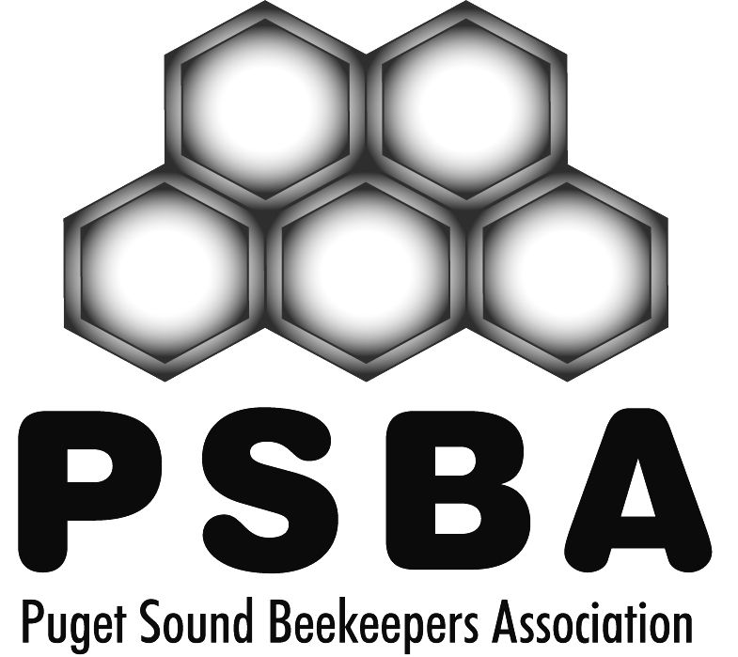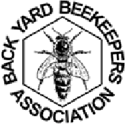

Participant’s Name: Birth date
Address/City/State:
Telephone: | Email:
Parents’ Name (if Participant is under age 18): | Parents’ Email:

Before participating in an event or project sponsored, sanctioned or supported by Puget Sound Beekeepers Association (a “PSBA Event”), all participants are required to read and sign this Waiver and Release of Liability before participating in such event or project. The Puget Sound Beekeepers Association is referred to as “PSBA.”

Waiver/Release and Assumption of Risk

In consideration of participating in a PSBA Event, and for other good and valuable consideration, the sufficiency of which is hereby acknowledged, the undersigned acknowledges, agrees and states that:
• There is a potential risk of injury or death from activities involved in beekeeping and activities related to beekeeping, and while particular rules, equipment and personal care may reduce this risk, the risk of injury or death does exist; and
• I KNOWINGLY, WILLINGLY AND FREELY ASSUME ALL SUCH RISKS, both known and unknown, EVEN IF ARISING FROM THE NEGLIGENT ACTS OR OMISSIONS OF PSBA, its employees, agents, officers, directors and members, or others, and assume full responsibility for my participation; and,
• I willingly agree to comply with the stated and customary terms and conditions for participation. I willingly agree to follow all safety rules for the event and the instructions of the instructor. If, however, I observe any unusual significant hazard during my presence or participation that may cause injury or harm to myself or others, I will remove myself from participation and bring such to the attention of the nearest instructor or PSBA representative immediately; and,
• For myself, and on behalf of my heirs, assigns, personal representatives and next of kin, HEREBY RELEASE AND HOLD HARMLESS the PSBA, its employees, agents, officers, directors and members, and if applicable, owners and lessors of the premises used to conduct the PSBA Event (collectively, “Releasees”), WITH RESPECT TO ANY AND ALL INJURY, DISABILITY, DEATH, OR LOSS OF OR DAMAGE TO PERSON OR PROPERTY, TO THE FULLEST EXTENT OF THE LAW, WHETHER ARISING FROM THE NEGLIGENCE OF THE RELEASEES OR OTHERWISE.
Please continue for minors
I HAVE READ THIS RELEASE OF LIABILITY AND ASSUMPTION OF RISK AGREEMENT, FULLY UNDERSTAND ITS TERMS, UNDERSTAND THAT I HAVE GIVEN UP SUBSTANTIAL RIGHTS BY SIGNING IT, AND SIGN IT FREELY AND VOLUNTARILY WITHOUT ANY INDUCEMENT AND ACKNOWLEDGE THAT I RECEIVED CONSIDERATION FOR EXECUTING THIS AGREEMENT.
(Next page)

___________________________________________________________________
(Printed Name)

______________________________DATE

___________________________________________________________________
(Participant’s Signature)

FOR PARTICIPANTS OF MINORITY AGE
(UNDER AGE 18 AT THE TIME OF REGISTRATION)
This is to certify and acknowledge that I, as parent or legal guardian with legal responsibility for the participant in a PSBA Event, do consent and agree to his/her release as provided above of all the Releasees, and for myself, my heirs, assigns, and next of kin, I release and agree to indemnify and hold harmless the Releasees from any and all liabilities incident to my minor child’s involvement or participation in these programs as provided above, EVEN IF ARISING FROM THE NEGLIGENT ACTS OR OMISSIONS OF RELEASEES.
_________________________________________________________
(Parent/Guardian and Child’s Name. Please Print)

__________________________________________________________________
(Parent/Guardian Signature)

Emergency Phone Number: ( )

MEDICAL INFORMATION:To my knowledge participant is _____/ is not ______ allergic (subject to anaphylactic shock) to honey bee stings.

PLEASE CONTINUE TO THE DAY OF WORK PARTY EMERGENCY CONTACT SHEET
THIS IS IMPORTANT

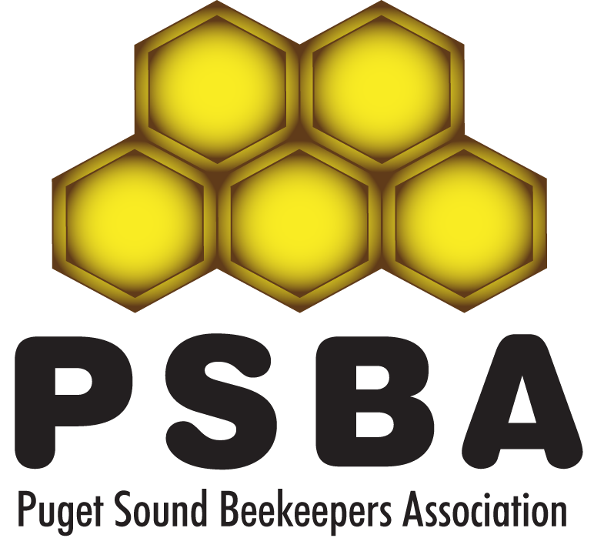Puget Sound Beekeepers Association

Emergency Contact Sheet

Information will be used only in an emergency in the Apiary-next page

Name | Phone | Alternate Phone

Immediate Local Contact

Immediate Local Contact
,

Family Contact

Physician name

Neighbor

Health Issue- Allergies?

