SUGGESTED BEGINNING EQUIPMENT LIST
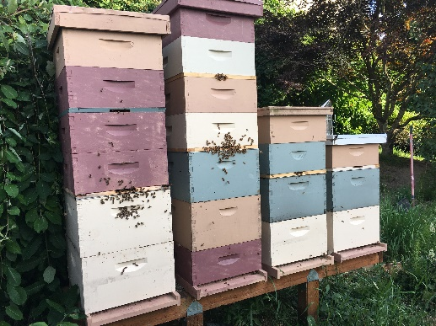
“Woodenware” Per Colony
1 Top (most hobbyists use telescoping tops)
1 (Notched) Inner Cover
2 Deep Boxes (or) 3 Medium Boxes (for brood chamber)*
2-3 Medium Boxes (for honey supers)
Frames & Waxed Foundation of choice (enough to fill each box)*
1 Queen Excluder (optional)
2 Drone Frames sized to match your brood boxes (optional)
1 Entrance Reducer
1 Robbing Screen (for use when hornets & yellow jackets become active)
1 Bottom Board (most hobbyists in NW use screened boards)
1 Feeder (top or frame)
Hive Stand
* 8-frame or 10-frame boxes available. This is human preference, the bees don’t really care, but then you must buy your other hive equipment to match.

Other Equipment
1 Smoker
1 Bee Suit
1 Pair Gauntleted Gloves
1 Hive Tool (if you order a J-hook tool you don’t need a frame lifter)
1 Frame Grip/Lifter
1 Frame Holder/Perch (optional)
1 Bee Brush (optional)

