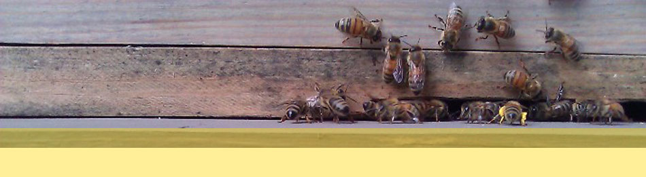

The PSBA Buzz

Volume No. 12

Issue No.9

Monthly Meetings are held every 4th Tuesday

(except July, Nov, Dec)

Location:

Graham Visitor Center of Washington Arboretum. 2200 Arboretum Drive E., Seattle, WA 98112

*Harvesting Honey?*

[*Rent a PSBA extractor*](http://www.pugetsoundbees.org/extractor-rentals/)

September Meeting:

* Beginner Lesson: 6:30-7:00pm
* Announcements: 7:00-7:15 Get the latest info on what’s happening with PSBA
* General Meeting 7:30–9:00pm Q&A with a panel of local beekeepers

September means it is time to think about preparing your colonies for winter.  Fireweed and pearly everlasting flows are ending so bees need to be migrated to the lowlands.  The nectar dearth in the lowlands beginning late July continues through August and into mid-September.  Fall blooms such as bindweed, aster, chrysanthemums and heptacodium provide some nectar and pollen so continue to supplement that with a 2:1 sugar syrup.    
  
Decrease the size of the hive to just the brood chambers using 2 deeps or 3 westerns and ensure that there is at least 50 pounds of honey.  One western frame of honey weighs 3-3.5 pounds and a deep frame of honey weighs roughly 7-8 pounds.  
  
Reduce the entrance to prevent mouse intrusions. Watch for robbing by stronger hives or yellow jackets – use robbing screens or reduce entrances accordingly.

# **Hive Calendar**

# **Bee Lunch**

## *By Jeff Steenbergen*



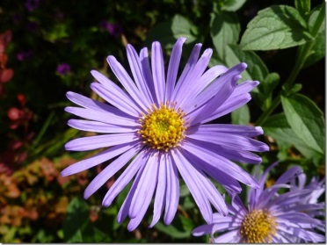

Asters - A Helpful Late Season Food Source

Asters are an autumn favorite for the bees with many native and hybrid options available to choose from.  When picking a variety remember that the bees prefer flowers with easy to access pollen.  Look for flowers with visible pollen at the center rather than a flower that is simply a mass of petals.  Some varieties grow in bushy clumps of various heights and others can grow a single long stem with multiple branches that may need to be staked if not trimmed mid-summer.  Asters range in colors from the shades of blue, pink and purple to even yellows so you have lots of different options for your fall garden.  While they can be grown from seed they also spread by root rhizomes in the ground and in just a few years a single plant will turn into a larger bee attracting clump.

Contents Title:

Bee Lunch 1

Hive Calendar 1

President’s Message 2

Winter Crops 2

Working in the Apiary-----------3

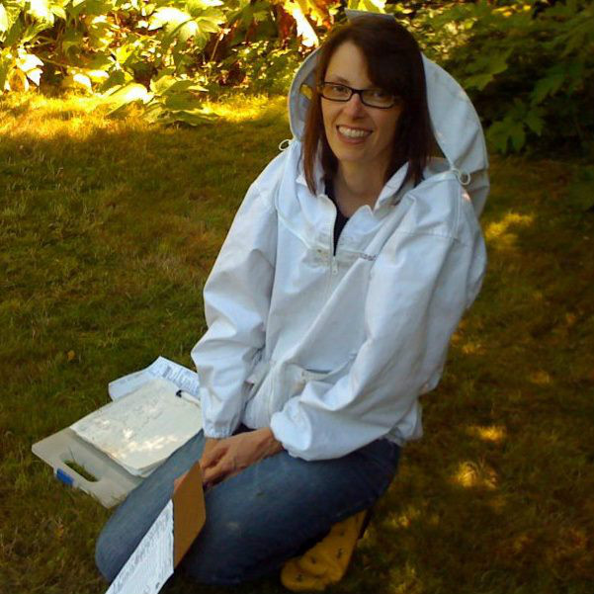

Even though we are still enjoying warm and sunny weather here in Puget Sound and honey harvesting is in full swing, beekeepers are also prepping hives for winter. If you aren’t sure what steps are needed to winterize *your* hives, I encourage you to find out – and quick! Some ways to learn more:

* Attend PSBA’s Day of Learning with Michael Bush, THIS Saturday8:30 – 4:30 pm More info online at [www.pugetsoundbees.org](http://www.pugetsoundbees.org)
* Come to PSBA’s September meeting where you’ll get a chance to get answers to all your tough beekeeping questions from a panel of local beekeepers.
* Attend a PSBA Apiary Work party to gain hands on experience in winterizing hives.
* Register for the Washington State Beekeepers Association Annual Conference – October 3-5 (more info pg 4).

We look forward to seeing you at one or more of these events!

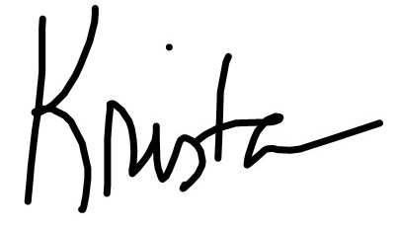

# **President’s Message** *Krista Conner*

Page 2

PSBA President:

Krista Conner

[](http://www.pugetsoundbees.org/psba-swarm-list/)

Planting A Winter Cover Crop That Doubles As Bee Forage

## *By Jeff Steenbergen*

Cover crops are a great way to protect and enrich your garden soil and can also provide early spring foraging options for the bees.  The main reasons gardeners plant cover crops is to replenish nutrients, keep the soil from compacting, stop erosion, and add organic material.  A cover crop isn't exclusive to winter and can be planted any time you want to give the soil a chance to rest and renew.

Any patches of bare garden soil will benefit from a cover crop going into winter and they are not limited to just vegetable garden plots and would even work for pots and planters that aren't in use.  Cover crops need very little care and are also great for helping keep winter and early spring weeds at bay.  Typically they only need to be watered for the first few weeks to get the seeds started or if there is a long stretch without any rain.

In the northwest with our mild winters there are many plants to pick from that make good cover crops however not all cover crops produce flowers that can also benefit the bees.  A few of the cover crops that produce flowers appealing to bees in early spring that I like are: Mustard, Winter peas, Crimson or White Clover and Fava Bean.  You don't need to plant just one type of crop either and a mix of plants can add variety and benefit the soil.

Cover crops usually start flowering a few weeks before you will want to till them into the ground to prep your spring gardens, but those February and early March flowers will be especially appealing for the bees when not much else is blooming.  Once the crop has flowered and you are ready to plant your garden in spring you can just cut down and till the plants right into the soil.  Planting a cover crop is relatively simple to do and come spring your bees will also be happy for the variety.

Working in the PSBA Apiary is fun and worthwhile. Truly.

*By Maureen Sullivan*

PSBA’s Apiary Work Parties this summer have proved to be challenging, entertaining and always educational. We have shared bees and bee business and philosophies with many folks who just happened to read about a work party and decide show up. And then they come back to the next work party.

The format of our parties changed this season to allow a work party leader time to go through the hives while a taskmaster (generally me) coerces attendees into cleaning gear, building boxes and frames, and organizing gear. Then they are released to hive show and tell.

Some Saturdays we have 15 people show up, sometimes five.

Sometimes the beekeeper protective clothing has to be changed around a few times (PSBA can always take donations of gear and we can sew up rips and torn veils if you have purchased a replacement). I try to insure that everyone can comfortably approach a slight squat to see. A few times, tall people are just plain uncomfortable and unable to bend for two hours.

We do not practice beekeeper-tipping in the Apiary.

Answering questions while you yourself are unsure as to what has ensued in the hive can be a challenge. This year we’re working on using [Hive Tracks](http://www.hivetracks.com) to log inspection notes, and when work party edicts are issued, short hive summaries are also given. This speeds up inspections and helps beginners to understand the why and how.

Making decisions (or decision trees) for public hives is very different than decisions for one’s backyard and local hives. Fortunately there are many experienced beekeepers who have answered endless questions and hypothetical situations presented late at night or on the phone.

Thanks to everyone who has shown up and contributed to the Apiary. We’ve identified significant areas of change and have made great progress in all. Old gear is being rotated to a faraway place, two eight-frame foundationless hives are running strong, and we’re improving and adding to the walkway displays. The bumblebees have prospered and multiplied thanks to Marvin Johnson’s kind treatment. The UW’s summer camps were introduced to bees and bumblebees and the joys of comb honey chewing.

However time-worn an adage, ‘many hands make light work’ is very true. Let’s hope all these decisions and all this work lead to high survival rates through the winter and spring in PSBA’s apiary.

PSBA Swarm List is a way to help protect honeybees – please share!

Page 3

Come See a Waggle Dance!

Danny Najera is offering viewing of waggle dances at Green River Community College. You can contact Danny at [dnajera@greenriver.edu](mailto:dnajera@greenriver.edu) if you want to set up an appointment or have event notices sent to you. Danny also does basic colony checks each Monday at 1:00 at Green River Community College if you want to learn more from an entomologist!

Upcoming…

The **2013 Washington State Beekeepers Association Annual** **Conference** is

October 3 – 5, 2013 at the Best Western Evergreen Inn and Suites located in Federal Way, WA.

**Learn about:** sustainable beekeeping practices, west coast beekeeping methods, the latest research in honeybee health, methods to raise your own queens.

Meet other beekeepers and learn about their methods, success and stories. Browse and shop from vendors offering a variety of beekeeping supplies and other items.

**Featured Speakers:**

* Les Crowder, co-author of Top Bar Beekeeping, talks about For the Love of Bees
* Howland Blackiston, author of *Beekeeping for Dummies*, presents JEAPORBEE
* Michael Bush, author of *The Practical Beekeeper*, gives “Four Simple Steps to Healthier Bees”
* Queen Rearing Methods – presentations by Paul Hosticka, WSBA Treasurer, and Morris Ostrofsky, Retired Biology Instructor.

To learn more visit <http://wasba.org/wsba-annual-conference-2013/>

PSBA OFFICERS

President

Krista Conner

206-938-5158

[president@psbees.org](mailto:president@psbees.org%20)

*Vice President*  
Kim Thomas

**206-778.0875**

[vp@psbees.org](mailto:vp@psbees.org)

Secretary

Maureen Sullivan   
206-715-7799

[secretary@psbees.org](mailto:secretary@pugetsoundbees.org)

Treasurer

Bruce Becker   
206-527-0226

[**treasurer@psbees.org**](mailto:treasurer@pugetsoundbees.org)

PSBA TRUSTEES

Jessica Dally (2012-13)

Lauren Englund(2013-14)

Gail Eshom (2013-14)

Mark Hohn (2013)

Barnaby Hoit (2012-13)

Brad Jones (ex-officio

President)

Amy Lassen (2013-14)

Daniel Najera(2013-14)

Jeff Steenbergen (2013-14)

John Woodworth (2012-13)

Robert Clark (Lifetime)

Bill Rahr (Lifetime)

Newsletter Editor   
Jessica Dally

[editor@psbees.org](mailto:editor@psbees.org)

Apiary Team

[apiary@psbees.org](mailto:apiary@psbees.org)

Volunteer Coordinator

Gail Eshom

[volunteer@psbees.org](mailto:volunteer@psbees.org)

Marketplace

**\*\*\* please** [**see our website**](http://pugetsoundbees.org/wp-content/uploads/2013/03/ad_policy_psba_marketplace3.9.13.pdf) **for new marketplace fees and guidelines \*\*\***

**Interested in advertising or sponsoring PSBA’s Newsletter? Get in touch!**

**Editor@psbees.org**

**Want to go for a spin?** We have spinner time available. Bring your frames and let the honey flow.  Convenient Eastside location.  You are welcome to share in the work or drop off your frames and container and pick up later. You help for only $1.5 per frame.  Call for details or to schedule time. Phone (425) 885-7011 or email [spinning@gooddoghoney.com](mailto:spinning@gooddoghoney.com)

PRSRT STD

U.S. POSTAGE PAID

CITY, STATE

YOUR PERMIT NO.

Puget Sound Beekeepers Association

Mailing address:

6535 42nd Ave NE

Seattle, WA 98115

/ / / /

_ ( / ( /

\\ /==\ / ||=||=|| \

(#)-/===-(=||=||=||=>

" \==/ \ ||=||=|| /

/ / /

\ \ \

We’re on the Web!

[www.pugetsoundbees.org](http://www.pugetsoundbees.org)

[www.psbees.org](http://www.psbees.org)

[Facebook](https://www.facebook.com/pages/Puget-Sound-Beekeepers-Association/257149984968?ref=ts#!/pages/Puget-Sound-Beekeepers-Association/257149984968?sk=wall&filter=2)

,